**• Explain about conditional rendering in React**

**Ans.** 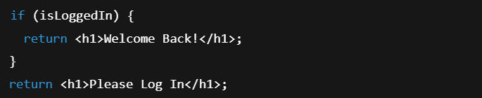

**• Define element variables**

**Ans.** Element variables are variables that hold JSX elements, which can then be rendered conditionally or reused.

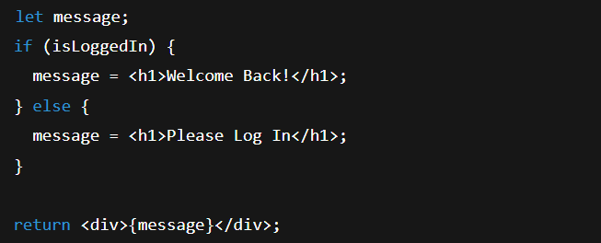

**• Explain how to prevent components from rendering**

**Ans.** 